mODIFIED Competition Rules
The Battle for Boston
Martial Arts Open
Tufts University
4/22/2012

Sponsored by The North American Karate Federation and the New England Collegiate Karate Conference.

Tournament Judging

The North American Karate Federation (NAKF) and the New England Collegiate Karate Conference (NECKC) use modified World Karate Federation forms and sparring competition rules.
The NAKF/NECKC tournament may comprise forms competition and/or sparring competition. The forms and sparring competition may be further divided into the team match and the individual match. The individual sparring match may be further divided into age and weight divisions. Age and weight divisions are divided ultimately into bouts. The term “bout” also describes the individual sparring competitions between opposing pairs of individuals and team members.

Before each team match, a team representative must hand into the official table, an official form
defining the names and fighting order of the competing team members. The participants drawn
from the full team of five members, and their fighting order, can be changed for each round provided the new fighting order is notified first, but once notified, it cannot then be changed until that round is completed. Teams can consist of three members. However, the three-member teams must win all three bouts in order to win the match.

A team will be disqualified if any of its members or its coach changes the team's composition or
fighting order without written notification prior to the round.

In multi-point matches, where an individual looses on account of receiving Hansoku or Shikkaku, any
score for the disqualified contestant will be set to nil, and a score of 8-0 will be recorded for that
bout in favor of the other contestant.

A sparring "Round Robin" is initiated for all matches with equal to three or less than three competitors, including teams.
The Chief Referee's powers and duties include:
Ensuring the correct preparation for each given tournament, including competition area arrangement, competitor draws, appointment of officials, match operation and supervision, safety precautions, etc.
Passing final judgements on matters of a technical nature that may arise during a given match and for which there are no stipulations in the rules.
The Arbitrator (Kansa)
An Arbitrator ("KANSA") shall be appointed for each match. The power and duties of the Arbitrator are to oversee the running of the match and to ensure that the rules are followed.
The Arbitrator is not there to assist the Referee and Judge in evaluating the scores.
The Arbitrator can, paradoxically, be involved at the request of the Referee in group decisions. This is rare and most often occurs when a judge feels the Arbitrator may have been better sighted.
An Arbitrator cannot halt the bout if he/she disagrees with a decision.
The power and duties of the Arbitrator also include the supervision and direction of the timekeeper and scorekeeper.

The Refereeing Panel for each sparring match shall consist of one Referee (SHUSHIN), three Judges (FUKUSHIN), and one Arbitrator (KANSA). If three Judges per match area is not possible, two Judges or the mirror system will be employed.

In addition, for facilitating the operation of matches, several timekeepers, caller announcers, record keepers, and score supervisors shall be appointed.
Competitors:
All college bouts will use one point scoring; Sanbon matches and Hantei for team forms.
College forms competition is REQUISITE Heians 1-5. Teams are five people, with substitutions at each match if desired. A team with a minimum three contestants can enter, but they have to win all three matches. They may elect any of the five Heians, and will perform them in order matching the opposing team when possible.
Except for the college and youth divisions, all individual sparring events will use the multi-point scoring system. Individual forms for all levels will use the 1 - 10 point grading system.
There will be a maximum of three-person teams in the Open Tournament. No synchronized forms.
Friendship sparring division will use the multi-point scoring system. Friendship division teams have the OPTION of continuing even if they have lost by majority.
The red and blue belts must be without any personal embroideries or markings, only the label of the manufacturer. Contestants must wear a white karate gi without stripes, piping or personal embroidery.
Match Area

The Match Area will be square with sides of 8 meters (26'), measured from the outside with an additional 2 meters on all sides as a safety area.

A line, one-half meter long, must be drawn 2 meters (6' 6") from the center of the competition area positioning the Referee.

Two parallel lines, each one meter long and at right angles to the Referee's line, must be drawn at a distance of 1.5 meters (4'11") from the center of the competition area for positioning the competitors.

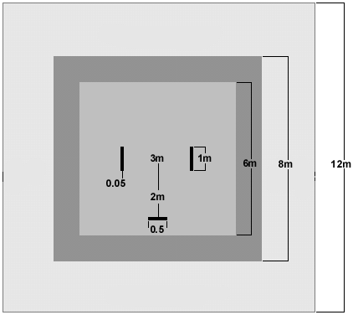

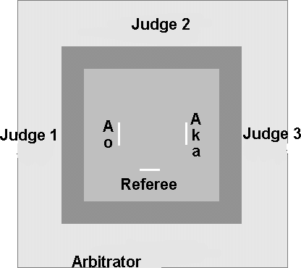

These powers are assigned to a Referee
- Conduct matches, including announcing the start, suspension, and end of the match
- Give commands and make announcements
- Award points
- Explain the basis for giving a judgment
- Conduct voting and announce the results
- Announce the winner
- Impose penalties and issue warnings, before, during, or after a bout

These powers are assigned to a Judge
- Use flag signals
- Signal when a score is observed
- Vote on a decision to be taken

In scoring the performance of a contestant or team, Judges will look for:
- A realistic demonstration of the kata meaning
- Understanding of the techniques being used
- Good timing, rhythm, speed, balance, and focus of power
- Correct focus of attention and concentration
- Correct stances with proper tension in the legs, and feet flat on the floor
- Correct and proper use of breathing as an aid in kime
- Proper tension in the abdomen
- Correct form of the style being demonstrated

The throat is a particularly vulnerable area and even a light, controlled "skin touch" contact should be warned or penalized unless the injury is caused by the recipient.

If one Judge signals Ippon for AKA, another Ippon for AO and the third Minenai along with the Referee, the Referee should give Torimasen.

The new definition for Jogai is "exit from the match area not caused by the opponent." Provided the contestant has not been physically propelled from the area, Jogai occurs at the moment any part of the contestant's body touches the floor outside of the match area. First incident of Jogai the contestant receives a warning (Chukoku). Second incident of Jogai, the contestant receives a warning (Keikoku) and one point is awarded to his/her opponent. Third incident of Jogai the contestant receives a warning (Hansoku chui) and two points are awarded to his/her opponent. Fourth incident of Jogai the contestant receives Hansoku (disqualification).

If two Judges signal a score for AKA or AO, the Referee must stop the match.

If competitor AKA or AO makes a good chudan kick and the opponent catches the leg, the score must be awarded.

A score is awarded when a technique is performed according to the following criteria to a scoring area:
- Good form
- Sporting attitude
- Strong (viorous) attitude
- Correct distance
- Awareness
- Appropriate control

An adult competitor shall be any athlete who is eighteen years of age or older.

Gum shields are compulsory in all divisions. Groin protectors are compulsory for all males competing in sparring matches.

Once a competitor has declared a particular category, then the competitor shall be deemed to be at that level of experience for all purposes.

Attacks are limited to the following areas:
- Head
- Face
- Neck (not including the throat)
- Chest
- Abdomen
- Side
- Back (not including the spine and kidneys)

A technique, which lands upon the shoulder blades, may score. The non-scoring part of the shoulder is the junction of the upper bone of the arm with the shoulder blades and collarbones.

Duration of all bouts are two minutes stop time.

One point is awarded for any punch (Tsuki) delivered to any of the seven scoring areas. Also,
any strike (Uchi) delivered to any of the seven scoring areas.

Two points are awarded for chudan kicks. Chudan being defined as the abdomen, chest, back and sides.

Three points are awarded for jodan kicks. Jodan being defined as the face, head and neck, not including contact to the throat.

Three points are also awarded for any scoring technique which is delivered within two seconds after an
opponent has been thrown, has fallen of their own accord, or is otherwise off their feet.

Prohibited Behaviors

There are two categories of prohibited behavior, Category 1 and Category 2.

Category 1(physical behavior)
- Techniques which make excessive contact, having regard to the scoring area attacked, and techniques which make contact with the throat
- Attacks to the arms or legs, groin, joints, or instep
- Attacks to the face with open hand techniques
- Dangerous or forbidden throwing techniques

Category 2 (personal behavior)
- Feigning, or exaggerating injury
- Repeated exits from the competition area (jogai)
- Self-endangerment by indulging in behavior, which exposes the contestant to injury by the opponent, or failing to take adequate measures for self-protection (mubobi)
- Avoiding combat as a means of preventing the opponent having the opportunity to score
- Passivity
- Clinching, wrestling, pushing, seizing or standing chest to chest, without attempting a throw, or other technique
- Techniques, which by their nature, cannot be controlled for the safety of the opponent, and dangerous and uncontrolled attacks
- Simulated attacks with the head, knees, or elbows
- Talking to, or goading the opponent
- Failing to obey the orders of the Referee
- Discourteous behavior towards the Refereeing officials, or other breaches of etiquette

Category 1 and Category 2 warnings and penalties do not cross-accumulate.
Penalties/Points:
A Chukoku (warning) is given where there has been a minor infraction of the rules, but the contestant's potential for winning is not diminished by the opponent's foul.
A Keikoku is a penalty in which Ippon (one point) is added to the opponent's score. It is awarded directly, without first giving a warning. Keikoku is normally imposed where the contestant's potential for winning is slightly diminished by the opponent's foul.
A Hansoku-Chui is a penalty in which Nihon (two points) is added to the opponent's score. It is imposed for minor infractions for which a Keikoku has previously been given in that bout. Hansoku-Chui is used where the contestant's potential for winning has been seriously reduced by the opponent's foul. The minimum warning for exaggeration of injury is Hansoku Chui (Cat 2). The minimum warning for running away, avoiding combat or wasting time during Atoshi Baraku is Hansoku Chui (Cat 2).
A Hansoku (disqualification) is imposed for cumulative penalties, but can also be imposed directly for serious rules infractions. It is used when the contestant's potential for winning has been reduced virtually to zero by the opponent's foul.
A Shikkaku is a disqualification from the actual tournament, competition or match. It may be invoked when a contestant fails to obey the orders of the referee, acts maliciously, or commits an act which harms the prestige and honor of Karate-do, or when other actions are considered to violate the rules and spirit of the tournament.
A Shikkaku can be directly imposed without warnings of any kind. The contestant need have done nothing to merit it -- it is sufficient if the coach, or non-combatant members of the contestant's delegation behave in such a way as to harm the prestige and honor of Karate-do.
For a point and/or a penalty to be given, there must be a majority of Judges, or at least one Judge and the Referee concurring. However, if only two Judges and a Referee are managing the match area, and two Judges call "no see", then their respective vote doesn't exist. The Referee becomes the majority and can award points for an observed score. Additionally, the Referee, as the majority, can issue warnings and penalties without concurrence of a Judge.
The Referee can request confirmation in cases of mubobi/contact or in cases of warnings verses penalties. Judges can indicate scores/penalties before the referee stops the bout. The Referee must stop the bout if two or more Judges signal a score, warning or penalty for the same competitor. The Referee has the ability to stop the match before the Judges give flag signals, but will always await the options of the Judges before announcing.
Judges, when giving points, are to keep the flags out until the Referee has announced the point. If two flags for the same contestant show a different score, the lower score will be applied. This same rule will apply to warnings and penalties.
However, when a contestant scores with more than one consecutive technique before "yame", the contestant will be awarded the higher point regardless of in which sequence the techniques scored. Example: If a kick followed a successful punch, the points for the kick would be awarded regardless if the punch scored first, as the kick has a higher point value.
Nevertheless, when there is a majority for a level of score, warning or penalty between the Judges, the majority will take precedence.
In individual matches, when a bout ends with equal scores, or no scores, the Referee will announce a tie (Hikiwake). A new, one minute match (Sai Shiai), will be declared. Prior to the start of the new match, both contestants' scores will be set to nil, and warnings and penalties removed. If no clear winner is decided at the end of the new match, the Referee will call for a judges' decision (Hantei). If the judge's decision results in a tie, the Referee's casting vote will decide the match.
Ties are permissible in team matches. Sai Shiai is used, if necessary, to decide team matche winners.
A new Category 2 prohibited behavior has been implemented: Passivity. The Referee signal is circling the fists around each other in front of the chest. The Judges signal is pointing the flags inward and circling them around each other.
The naming of points remain as follows: Ippon (1 point), Nihan (2 points), Sanbon (3 points).

Sanbon is awarded for:
a) Jodan kicks
b) Any scoring technique delivered on a thrown or fallen opponent

Nihon is awarded for: Chudan kicks

Ippon is awarded for:
a) Chudan or Jodan Tsuki
b) Chudan or Jodan Uchi

An effective technique delivered at the same time that the end of the bout is signaled is
considered valid. A technique even if effective, delivered after an order to suspend or stop the
bout shall not be scored, and may result in a warning or penalty being imposed.

No technique, even if technically correct, will be scored if it is delivered when the two contestants
are outside the competition area. However, if one of the contestants delivers an effective
technique while still inside the competition area and before the Referee calls “YAME”, the
technique will be scored.

For reasons of safety, throws where the opponent is grabbed below the waist, thrown without
being held onto, or thrown dangerously, or where the pivot point is above belt level, are prohibited and will incur a warning or penalty. Exceptions are conventional karate leg sweeping techniques, which do not require the opponent to be held while executing the sweep such as de ashi-barai, ko uchi gari, kani waza etc.

After a throw has been executed the Referee will allow the contestant two seconds in which to attempt a scoring technique.

When a contestant is thrown according to the rules, slips, falls, or is otherwise off their feet and is scored upon by the opponent, the score will be Sanbon.

A technique with “Good Form” is said to have characteristics conferring probable effectiveness within the framework of traditional Karate concepts.

Sporting Attitude is a component of good form and refers to a non-malicious attitude of great
concentration obvious during delivery of the scoring technique.

Vigorous Application defines the power and speed of the technique and the palpable will for it to succeed.

Zanshin is that criterion most often missed when a score is assessed. It is the state of continued commitment in which the contestant maintains total concentration, observation, and awareness of the opponent's potentiality to counter-attack. He does not turn his face away during delivery of the technique, and remains facing the opponent afterwards.

Good Timing means delivering a technique when it will have the greatest potential effect.

Correct Distance similarly means delivering a technique at the precise distance where it will have the greatest potential effect. Thus if the technique is delivered on an opponent who is rapidly moving away, the potential effect of that blow is reduced.

Distancing also relates to the point at which the completed technique comes to rest on or near the target. A punch or kick that comes somewhere between skin touch and 5 centimeters (2 inches) from the face, head, or neck may be said to have the correct distance. However, Jodan techniques, which come within 5 centimeters (2 inches) distance of the target and which the opponent makes no attempt to block or avoid will be scored, provided the technique meets the other criteria. In Cadet and Junior competition no contact to the head, face, or neck, (or the face mask) is allowed other than a very light touch (previously known as a “skin touch”) in advanced youth division only.

A worthless technique is a worthless technique —- regardless of where and how it is delivered. A technique, which is badly deficient in good form, or lacking power, will score nothing, and may incur a warning or penalty.

Techniques which land below the belt are not permitted, and may incur a warning or penalty. Techniques must land no lower than the belt to receive a score.

The time-up bell signals the end of scoring possibilities in that bout, even though the Referee may inadvertently not halt the bout immediately. The time-up bell does not, however, mean that penalties cannot be imposed.

If two contestants hit each other at the exact same time, the scoring criterion of “good timing” has by definition not been met, and the correct judgment is to not award a point (aiuchi).

Youth divisions in which all techniques to the face, head, and neck must have absolute control, are defined as: 1) age 13 and younger, 2) age 14 - 17 (beginner, novice and intermediate).

Youth divisions in which non-injurious, light, controlled "touch" contact to the face, head, and neck are allowed with foot techniques are defined as age 14 - 17 (advanced).

AO attacks with chudan geri, which AKA blocks and then immediately scores with chudan tsuki to AO's abdomen. The correct score is Ippon for AKA.

AKA hits AO in the back with chudan tsuki and immediately turns away with his fist in the air. The correct decision is Ippon and a Category 2 Mubobi for AKA.

A contestant delivers a scoring technique for which the Referee calls "Yame", but immediately thereafter makes contact to his opponent's face. The contestant should receive the score and a Category 2 warning for failing to obey the Referee's order.

Attacks to the arms or legs, groin, joints or instep can be given a Category 1warning or penalty, depending on the seriousness of the offense.

AO crosses the Jogai line just as AKA scores, but AKA remains within the match area. The correct decision should be a Category 2 warning for AO, and a score given to AKA.

When the bout is halted, the Referee may not give a decision against two Judges unless he has the casting vote.

A contestant, who grabs an opponent for more than two seconds without throwing the opponent, or making a technique, will be given a Category 2 warning.

Shobu Contest, match, competition
Shobu Hajime Start the match, or bout
Atoshi Baraku A little more time left
Yame Stop, or end the bout
Moto No Ichi Return to original, or starting position
Tsuzukete Fight on
Tsuzukete Hajime Resume fighting, begin
Hantei Decision, judgment - Referee and Judges verdict
Fukushin Shugo Judges called
Hikiwake Draw
Torimasen Unacceptable as a scoring technique
Aiuchi Simultaneous scoring techniques
Chukoku Category 1 or 2 warning without penalty
Keikoku Category 1 or 2 warning with Ippon penalty
Hansoku-chui Category 1 or 2 warning with Nihon penalty
Hansoku Disqualification
Shikkaku Disqualification "leave the area"
Jogai Chui Exit from the match area warning
Jogai Keikoku Exit from the match area 1-point penalty
Jogai Hansoku-chui Exit from the match area 2-point penalty
Jogai Hansoku Exit from the match area disqualification
Kiken Renunciation, (retirement through injury)
Mubobi Self endangerment
Otagai-ni-rei Contestants bow to each other

GESTURES AND FLAG SIGNALS

ANNOUNCEMENTS AND GESTURES OF THE REFEREE

SHOMEN-NI-REI
The Referee extends his arms palms to the front.

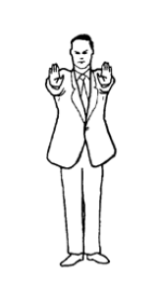

SHOBU HAJIME
"Start the Match”
After the announcement, the Referee takes a step back.
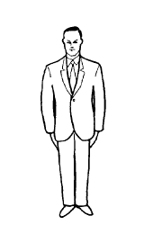

YAME
"Stop”
Interruption or end of a match or bout. As he makes the announcement, the Referee makes a downward chopping motion with his hand.

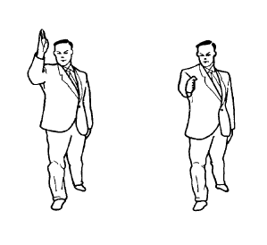

OTAGAI-NI-REI
The Referee motions to the contestants to bow to each other.

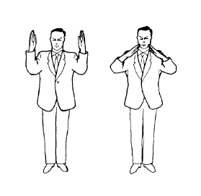

TSUZUKETE HAJIME
"Resume fighting—Begin” As he says “Tsuzukete”, and standing in a forward stance, the Referee extends his arms outward with his palms facing the contestants. As he says "Hajime” he turns the palms and brings them rapidly towards one another at the same time stepping back.

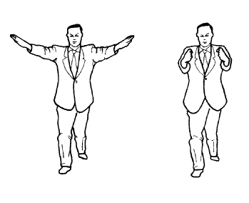

IPPON (One point)
The Referee extends his arm downward at 45 degrees on the side of the scorer.
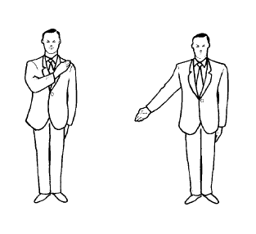

NIHON (Two Points)
The Referee extends his arm at shoulder level on the side of the scorer.

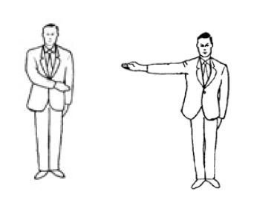

SANBON (Three Points)
The Referee extends his arm upward at 45 degrees on the side of the scorer.

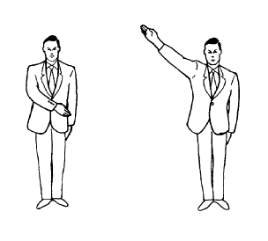

NO KACHI (Win)
At the end of the match or bout, announcing “AKA (or AO) No Kachi” the Referee extends his arm upward at 45 degrees on the side of the winner.

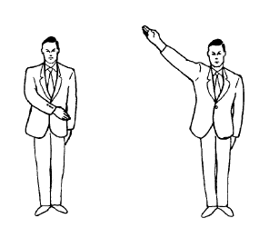

CANCEL LAST DECISION
When an award or penalty has been given in error, the Referee turns towards the contestant, announces “AKA” or “AO”, crosses his arms, then makes a cutting motion, palms downward, to indicate that the last decision has been cancelled.

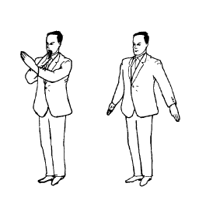

KIKEN
"Renunciation”
The Referee points with the index finger towards the renouncing contestant's line then announces a win to the opponent.

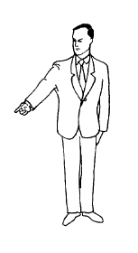

SHIKKAKU
“Disqualification, Leave the Area”.
The Referee points first upwards at 45 degrees in the direction of the offender then motions out and behind with the announcement “AKA (AO) SHIKKAKU!” He then announces a win for the opponent.

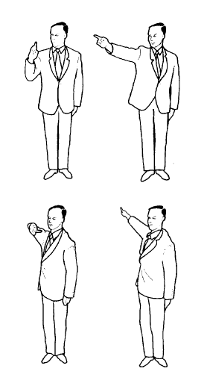

HIKIWAKE
“Draw” (Only applicable to team matches).
When time is up and scores are equal, or no scores have been awarded. The Referee crosses his arms then extends them with the palms showing to the front.

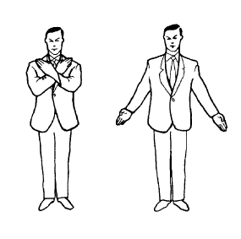

CATEGORY 1 OFFENSE (used without further signal for CHUKOKU)
The Referee crosses his open hands with the edge of one wrist on the edge of the other at chest level.

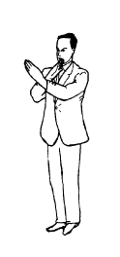

CATEGORY 2 OFFENSE (used without further signal for CHUKOKU)
The Referee points with a bent arm at the face of the offender.

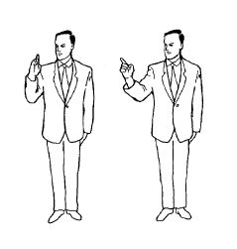

KEIKOKU
“Warning”. The Referee indicates a Category 1 or 2 offense then points with his index finger downwards at 45 degrees in the direction of the offender.
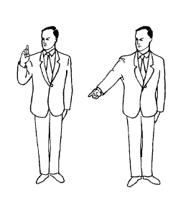
HANSOKU CHUI
“Warning of disqualification”.
The Referee indicates a Category 1 or 2 offense then points with his index finger horizontally in the direction of the offender.

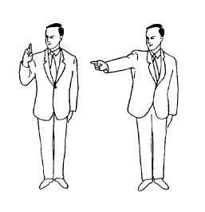

HANSOKU
“Disqualification” The Referee indicates a Category 1 or 2 offence then points with his index finger upwards at 45 degrees in the direction of the offender, and awards a win to the opponent.

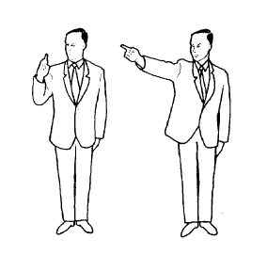

PASSIVITY
The Referee rotates his fist around each other in front of his chest to indicate a Category 2 offence.
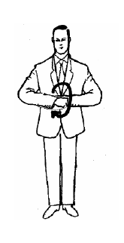

TORIMASEN
“No score, warning or penalty”
The Referee crosses his arms then makes a cutting motion, palms downward.

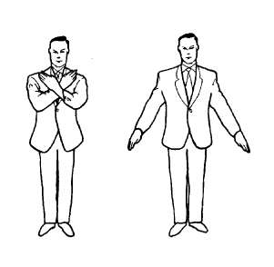

TECHNIQUE BLOCKED OR OFF TARGET
The Referee places an open hand over the other arm to indicate to the Judges that the technique was blocked or hit a non-scoring area.
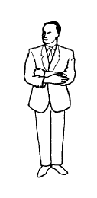

TECHNIQUE MISSED
The Referee moves the clenched fist across the body to indicate to the Judges that the technique missed or glanced off the scoring area.
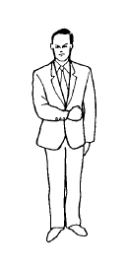

EXCESSIVE CONTACT
The Referee indicates to the Judges that there has been excessive contact or other Category 1 offense.

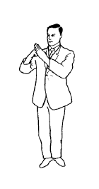

FEIGNING OR EXAGGERATING INJURY
The Referee holds both hands to his face to indicate to the Judges a Category 2 offense.

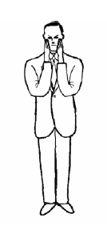

JOGAI
“Exit from the Match Area” The Referee indicates an exit to the Judges, by pointing with the index finger to the match area boundary on the side of the offender.

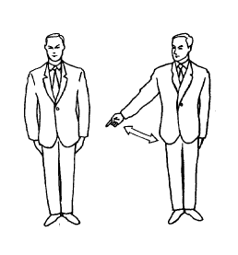
MUBOBI (Self Endangerment)
The Referee touches his face then turning the hand edge forward, moves it back and forth to indicate to the Judges that the contestant has endangered himself.

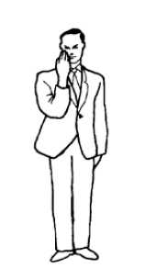

AVOIDING COMBAT
The Referee makes a circling motion with the down turned index finger to indicate to the Judges a Category 2 offense.

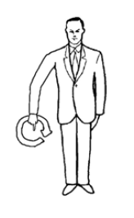

PUSHING, SEIZING OR STANDING CHEST TO CHEST
WITHOUT ATTEMPTING A TECHNIQUE WITHIN 2 SECONDS
The Referee holds both clenched fists at shoulder level or makes a pushing motion with both open hands to indicate to the Judges a Category 2 offense.
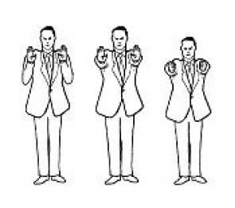

DANGEROUS AND UNCONTROLLED ATTACKS
The Referee brings his clenched fist past the side of his head to indicate to the Judges a Category 2 offense.

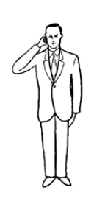

SIMULATED ATTACKS WITH THE HEAD KNEES OR ELBOWS
The Referee touches his forehead, knee, or elbow with the open hand to indicate to the Judges a Category 2 offense.

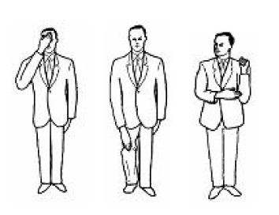

TALKING TO OR GOADING THE OPPONENT AND DISCOURTEOUS BEHAVIOUR
The Referee places his index finger to his lips to indicate to the Judges a Category 2 offense.

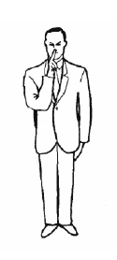

SHUGO
“Judges Called”
The Referee calls the Judges at the end of the match or bout or to recommend SHIKKAKU.

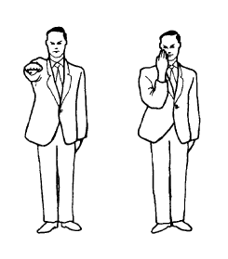

THE JUDGE´S FLAG SIGNALS

IPPON (1 point)

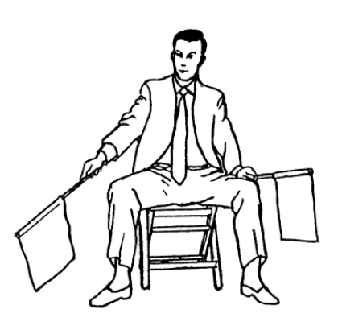

NIHON (2 points)

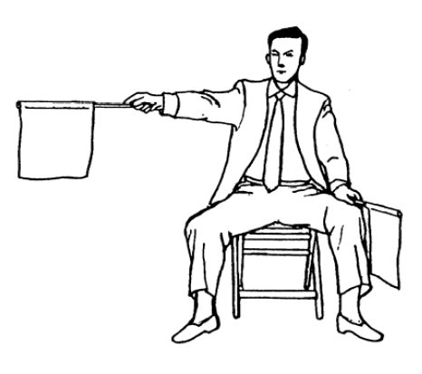

SANBON (3 points)

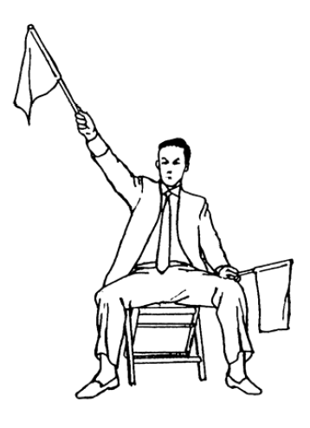

FAULT
Warning of a foul. The appropriate flag is waved in a circle, then a Category 1 or 2 signal is made.
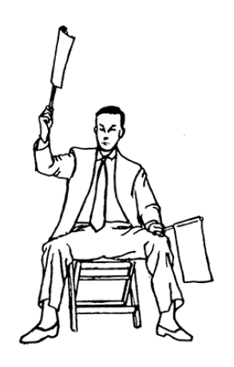

Category 1 Offense

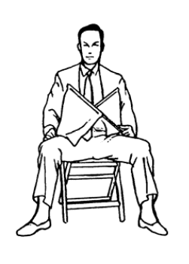

Category 2 Offense

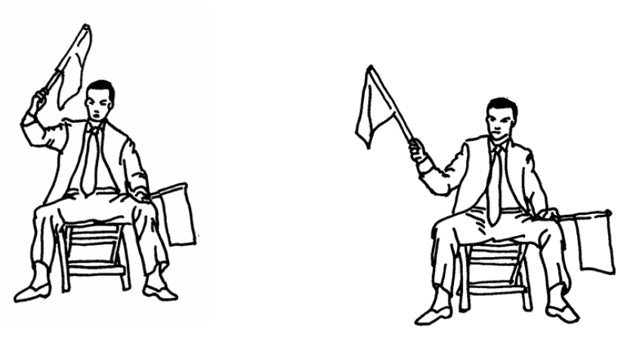

Jogai

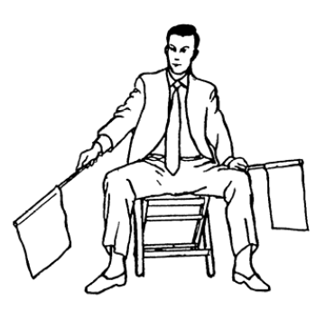

Passivity

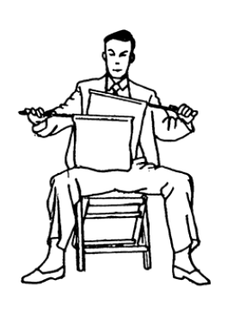

Keikoku

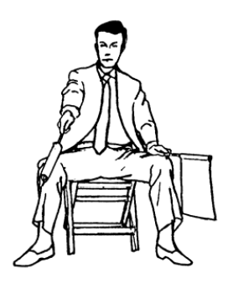

Hansoku-chui
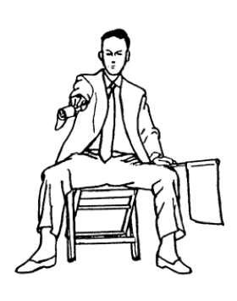

Hansoku

